**Katun Points Up Program Mod**

Katun’s Points Up Program is made up of a series of custom objects that support their current Apps 8 environment. The functionality requires changes to the baseline Create Invoice flow.

These changes have been accomplished via a combination of 1 modified core code file, 6 custom PL/SQL methods, 3 custom tables, and 2 custom sequences. The custom objects are currently spread across 3 different schemas: KATUNAPP (app owner), KTNA and KTNAPOS. The requirement is to recreate this functionality in build place so that it can be delivered to Katun’s new Cloud environment as a modification.

The custom functionality begins with additions to CUSTOMER_ORDER_FLOW_API.Create_Invoice___. That core code modification and the subsequent downstream methods and their dependencies are described below.

KATUNAPP.CUSTOMER_ORDER_FLOW_API.Create_Invoice___ has been modified to contain a custom variable and several calls to custom methods:

KTNA.KTNA_REWARDS_PROG_PKG.GET_CUST_IN_PROG_FLAG returns Y or N depending on CUSTOMER_NO. This method depends on the following custom database object:

1. KTNAPOS.KPOS_CUST_PROG_XREF_TAB

KTNAPOS.KPOS_CUST_PROG_XREF_TAB contains the following columns:

If in_cust_prog = ‘Y’ (if the customer belongs to the points up program), then KTNA.KTNA_REWARDS_PROG_PKG.UPD_CHG_LINE_PRE_INVOICING is called. This method depends on the following custom database objects:

1. KTNA.KTNA_REWARDS_PROG_PKG.GET_LINE_AMOUNT_BY_QTY
2. KTNA.KTNA_REWARDS
3. KTNA.KTNA_ERRHNDL_PKG.LOG_OP_EXTENDED_ERROR
4. KTNA_EM_ERR_SEQ

KTNA.KTNA_REWARDS_PROG_PKG.GET_LINE_AMOUNT_BY_QTY depends on the following custom database objects:

1. KTNA.KTNA_ERRHNDL_PKG.LOG_OP_EXTENDED_ERROR

KTNA.KTNA REWARDS contains the following columns:

KTNA.KTNA_ERRHNDL_PKG.LOG_OP_EXTENDED_ERROR depends on the following custom database objects:

1. KTNA.KTNA_EM_ERR
2. KTNA.KTNA_EM_ERR_SEQ

KTNA.KTNA_EM_ERR is a custom table containing the following columns:  
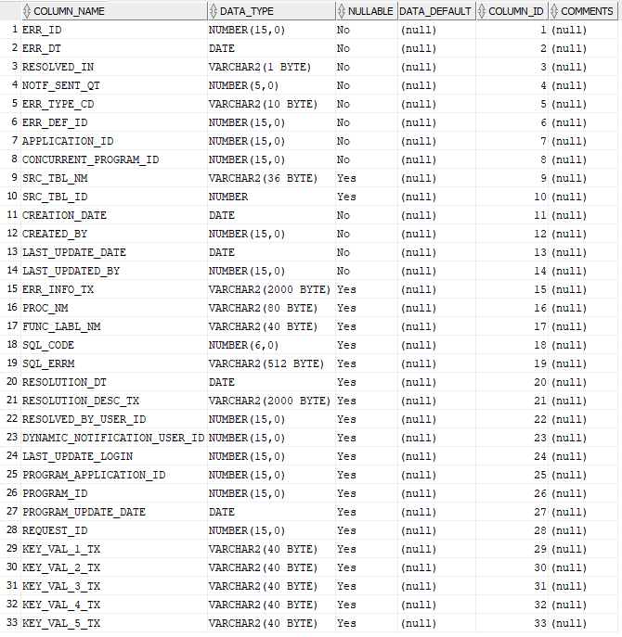

After the above methods execute, then the original Create_Invoice___ code executes.

The final block of custom code potentially calls KTNA.KTNA_REWARDS_PROG_PKG.CHANGE_REWARD_EARNINGS_STATUS and KTNA.KTNA_REWARDS_PROG_PKG.ADD_CHG_LINE_POST_INVOICE. These methods depend on the following custom database objects:

1. KTNA.KTNA_REWARDS
2. KTNA.KTNA_REWARD_SEQ
3. KTNA.KTNA_ERRHNDL_PKG.LOG_OP_EXTENDED_ERROR

The zip folder containing this spec also contains code files for the necessary database objects. Below is a summarized list of unique custom objects described in the spec:

1. CUSTOMER_ORDER_FLOW_API.Create_Invoice___
2. KTNA_REWARDS_PROG_PKG.GET_CUST_IN_PROG_FLAG
3. KTNAPOS.KPOS_CUST_PROG_XREF_TAB
4. KTNA.KTNA_REWARDS_PROG_PKG.UPD_CHG_LINE_PRE_INVOICING
5. KTNA.KTNA_REWARDS_PROG_PKG.GET_LINE_AMOUNT_BY_QTY
6. KTNA.KTNA_REWARDS_PROG_PKG.CHANGE_REWARD_EARNINGS_STATUS
7. KTNA.KTNA_REWARDS_PROG_PKG.ADD_CHG_LINE_POST_INVOICE
8. KTNA.KTNA_REWARDS
9. KTNA.KTNA_REWARDS_SEQ
10. KTNA.KTNA_ERRHNDL_PKG.LOG_OP_EXTENDED_ERROR
11. KTNA.KTNA_EM_ERR
12. KTNA.KTNA_EM_ERR_SEQ